**Employee Attrition Dataset Analysis**

**Using Power BI**

**1.Context**

Employee attrition is a key challenge for organizations, impacting productivity, costs, and overall business growth. This analysis aims to identify patterns and reasons behind employee turnover to help improve retention strategies.

**2.Objective**

To analyse attrition trends based on factors like age, department, salary, work-life balance, and job satisfaction. To identify key drivers of employee turnover and their impact on retention. To provide data-driven insights to HR for improving employee engagement and reducing attrition.

**3.Scope**

Covers employee demographic data, salary details, job satisfaction, work-life balance, and attrition status. Focuses on identifying high-risk groups and key reasons for attrition. Recommends strategies to improve employee retention and satisfaction.

**4.Audience**

* Job seekers & employees – To understand salary trends and career growth potential
* HR & recruiters – To benchmark salaries for different roles and experience levels
* Business leaders & policymakers – To analyse workforce trends and gender pay gaps
* Data analysts & students – To practice SQL, data visualization, and dashboard creation

**5.Dataset Overview**

* **Dataset Name -** Employee Attrition Dataset
* **Data Source -** HR records containing employee details related to attrition, demographics, compensation, job roles, and work-life balance.
* **Number of Records –** 1000+ rows and 30+ columns

**6. Data Cleaning**

* Removed missing or duplicate records.
* Standardized salary bands and grouped ages into categories.
* Created calculated columns for Attrition Rate, Retention Rate, and Salary Bands using DAX in Power BI.

**Purpose of the Dataset**

This dataset helps analyse employee attrition trends, reasons for turnover, and factors influencing retention. The insights guide HR teams in developing better employee retention strategies.

**7.Key Observations & Trends from the Data**

**Attrition Rate:**

* The overall attrition rate is 17.1%, meaning a significant portion of employees leave the company.
* Retention rate is 82.9%, indicating most employees stay, but there are areas of concern.

**Age Group Trends:**

* Young employees (18-25 years) have the highest attrition (>40%), suggesting they seek better opportunities.
* Attrition decreases with age, indicating older employees are more stable in their jobs.

**Department-Wise Insights:**

* Sales (22.2%) and HR (19%) have the highest attrition rates, possibly due to high workload or job dissatisfaction.
* R&D has the lowest attrition, suggesting better engagement and stability.

**Salary & Compensation Influence:**

* Employees with low salaries (below $3,000) have the highest attrition (23.1%).
* High earners (above $6,000) have lower attrition (7.8%), showing that better pay improves retention.

**Work-Life Balance & Job Satisfaction:**

* Employees with poor work-life balance (Rating 1) have the highest attrition.
* Low job satisfaction leads to higher turnover, emphasizing the need for employee engagement programs.

**Stock Options & Benefits:**

* Employees with no stock options (44.3% attrition rate) leave more frequently.
* Providing better financial incentives can help retain employees.

**Business Travel Impact:**

* Employees who travel frequently (24.5% attrition rate) are more likely to leave, suggesting travel-related stress.

**Education & External Opportunities:**

* Employees with Technical Degrees and HR backgrounds show higher attrition, possibly due to better external job opportunities.

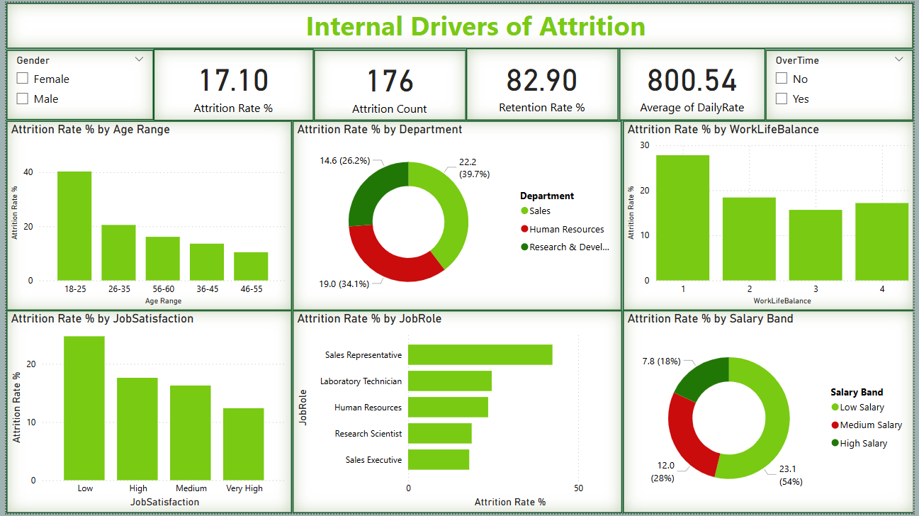

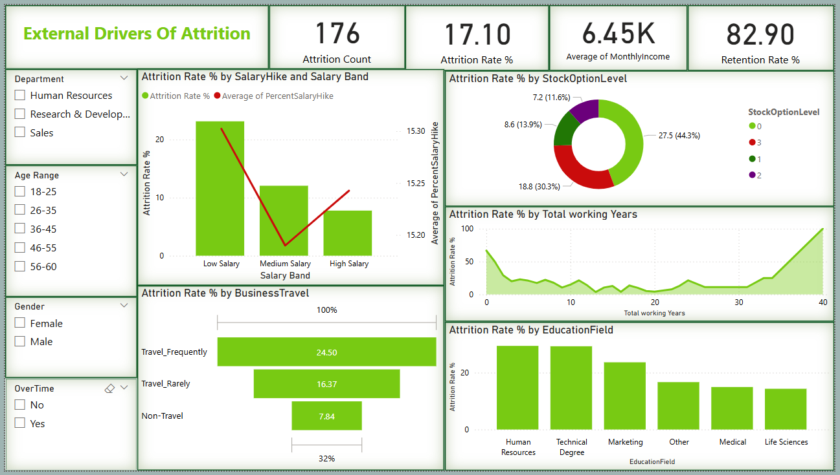

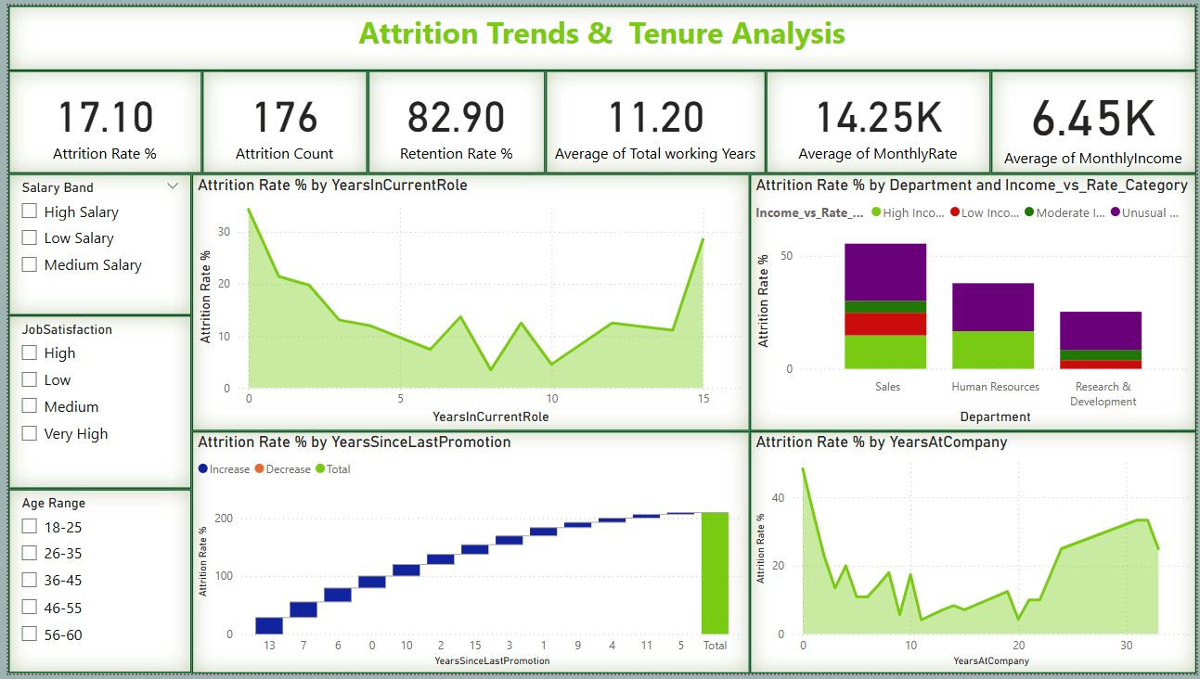

**8.Significant Patterns, Anomalies, & Relationships Identified**

**1️.** **Young Employees Leave More Often**

* Employees aged 18-25 have the highest attrition (>40%), showing that younger employees are more likely to leave for better opportunities.
* Attrition decreases with age, indicating that older employees tend to stay longer.

**2️.** **Sales & HR Departments Have High Attrition**

* Sales (22.2%) and HR (19%) have the highest attrition rates, possibly due to high job pressure, dissatisfaction, or limited growth opportunities.
* R&D has the lowest attrition, suggesting better job engagement and stability.

**3️.** **Low Salary = High Attrition**

* Employees earning less than $3,000/month have a 23.1% attrition rate, while those earning above $6,000 have only 7.8% attrition.
* This confirms that higher salaries improve retention.

**4️.** **Job Satisfaction & Work-Life Balance Impact**

* Employees with low job satisfaction (Rating 1-2) have significantly higher attrition.
* Work-life balance issues contribute to turnover, as employees with poor balance leave more often.

**5️.** **Frequent Business Travelers Leave More**

* Employees who travel frequently (24.5% attrition rate) are more likely to quit, suggesting that travel stress affects retention.

**6️.** **Stock Options & Benefits Influence Retention**

* Employees without stock options have a 44.3% attrition rate, much higher than those with benefits.
* Providing better incentives can help reduce turnover.

**9. Anomalies & Unexpected Insights**

**1.** **Mid-Level Employees Also Show High Attrition**

* While young employees leave more often, there is an unexpected spike in attrition among employees with 5-7 years of experience.
* This suggests that career stagnation or lack of promotions may be a problem.

**2.** **Some High-Salary Employees Still Leave**

* While most high earners stay, some employees earning $7,000+ still leave, indicating that salary alone is not enough—job satisfaction also plays a big role.

**3.** **Technical & HR Employees Have Higher Attrition**

* Employees with Technical and HR degrees leave more often, likely due to strong external job opportunities in their fields.

**4. Unusual Cases (Monthly Rate > Monthly Income)**

* This is unexpected since monthly rate should be a part of monthly income.
* Possible reasons:
  + Data entry errors or inconsistencies.
  + Different pay structures, where some earnings are excluded from base income.
  + Variable compensation models, where commissions or bonuses fluctuate.

Expected Cases (Monthly Income > Monthly Rate)

* This is the normal scenario, where income includes base salary, bonuses, and incentives.
* Indicates employees receive fixed salaries plus additional earnings such as commissions or stock options.

Impact & Recommendations

* Identify and investigate anomalies where monthly rate exceeds income.
* Categorize employees based on income differences to analyse pay structures.
* Ensure consistent salary calculations and fix potential data issues in HR records.

**10. Recommendations & Action Plan**

Based on the analysis, the following recommendations can help reduce attrition and improve employee retention.

**1. Improve Retention Among Young Employees**

* Provide career development programs and mentorship for employees aged 18-25 to reduce high attrition.
* Offer clear promotion paths and skill enhancement training to increase engagement.

**2. Address High Attrition in Sales & HR Departments**

* Review job roles and workload in Sales & HR to identify stress factors.
* Implement incentives, recognition programs, and better work conditions to improve satisfaction.

**3. Increase Compensation & Financial Benefits**

* Adjust salary structures to ensure competitive pay, especially for employees earning below $3,000.
* Provide stock options and performance-based bonuses to enhance job satisfaction.

**4. Enhance Work-Life Balance & Job Satisfaction**

* Introduce flexible work schedules and remote work options where possible.
* Address overtime issues and promote work-life balance initiatives.

**5. Reduce Business Travel Stress**

* Minimize frequent travel for employees by optimizing virtual meetings and alternative work arrangements.
* Provide better travel allowances and support for employees who need to travel.

**6. Retain Mid-Level Employees (5-7 Years Experience)**

* Offer leadership programs and career growth opportunities to prevent stagnation.
* Create internal mobility options for employees seeking new challenges within the company.

**11. Conclusion**

1. The employee attrition analysis highlights several key factors driving turnover within the organization. The data shows that young employees, particularly those aged 18-25, have the highest attrition rates, suggesting a need for better career growth opportunities and engagement strategies. Additionally, the Sales and HR departments experience significantly higher turnover, likely due to job dissatisfaction and workload challenges. Compensation also plays a major role, as employees with lower salaries and limited benefits tend to leave at a much higher rate, whereas competitive pay and stock options improve retention. Furthermore, work-life balance and job satisfaction are critical factors influencing attrition, with employees facing poor work-life balance and excessive travel showing higher turnover. Mid-level employees, particularly those with 5-7 years of experience, also exhibit unexpected attrition trends, possibly due to career stagnation or lack of internal growth opportunities.
2. To address these issues, organizations must focus on targeted retention strategies, including competitive salary adjustments, employee engagement initiatives, flexible work policies, and structured career development programs. By implementing these changes, businesses can reduce turnover, improve job satisfaction, and create a more stable and motivated workforce. This analysis serves as a data-driven foundation for HR teams to make informed decisions and foster long-term employee retention.

**Date :** 07-04-2025 **By,**

**Yahavarshini E**